**CSA1702: ARTIFICIAL INTELLIGENCE**

EXPERIMENT 1:

**EXPERIMENT 2:**

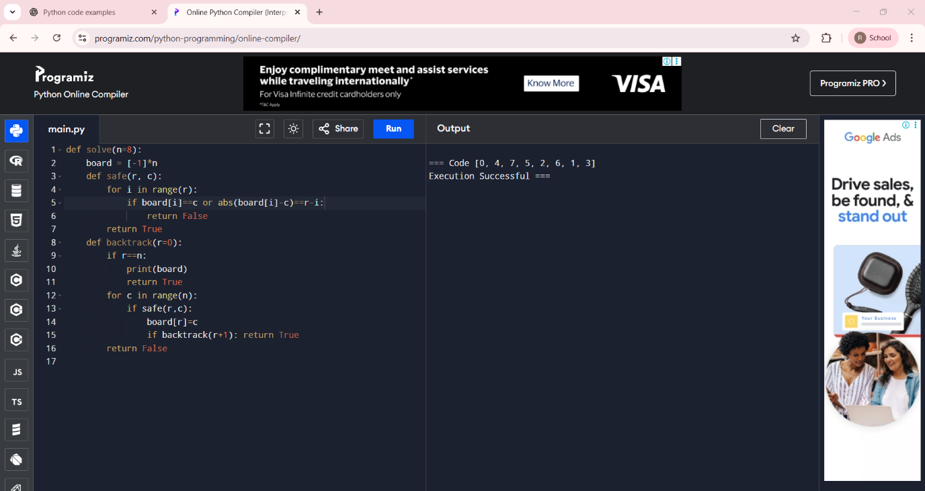

**EXPERIMENT 3**:

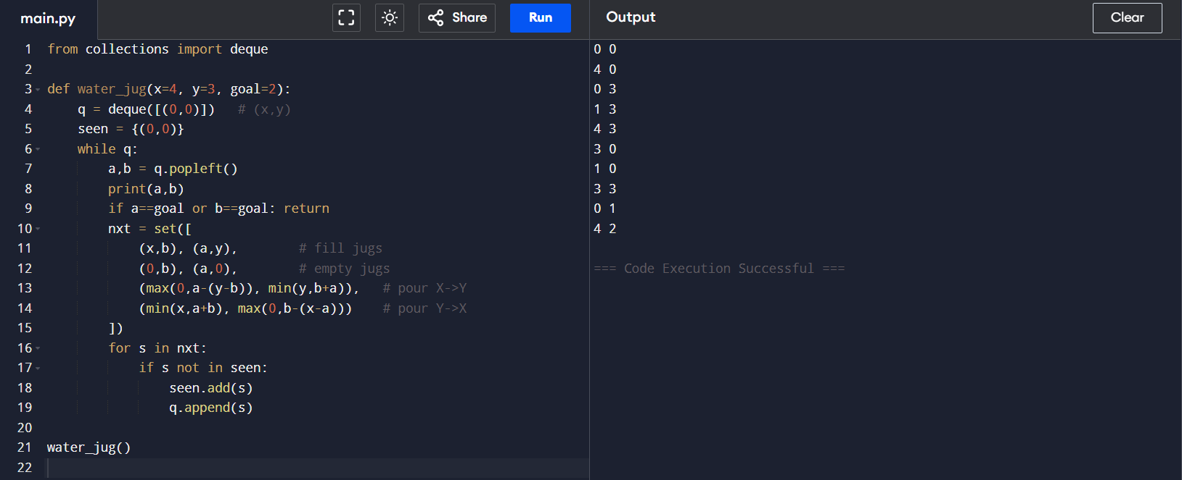

EXPERIMENT 4:

EXPERIMENT 5:

**EXPERIMENT 6:**

**EXPERIMENT 7:**

**EXPERIMENT 8:**

**EXPERIMENT 9:**

**EXPERIMENT 10:**

**EXPERIMENT 11:**

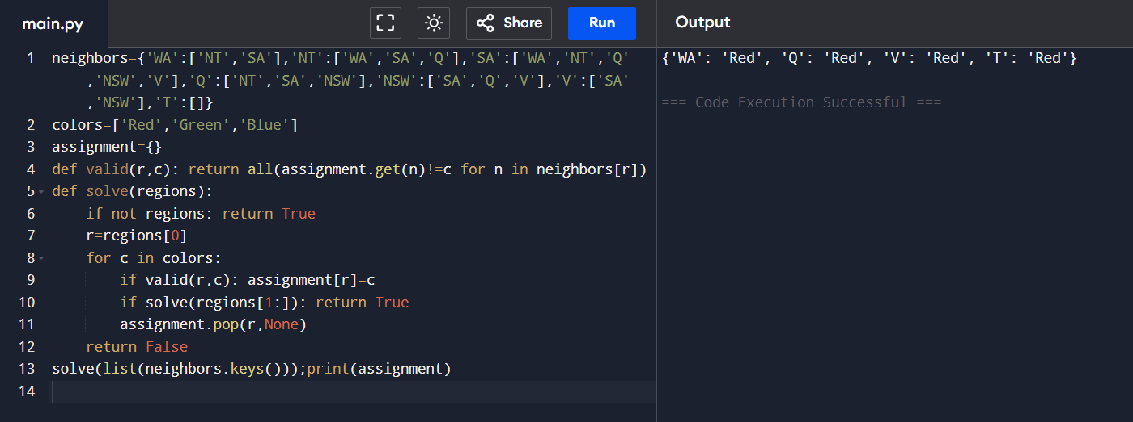

**EXPERIMENT 12:**

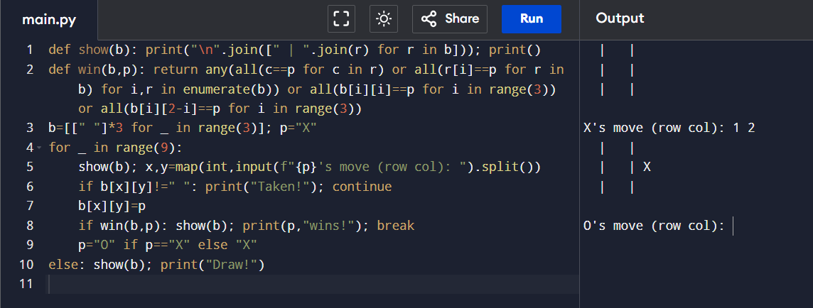

**EXPERIMENT 13:**

**EXPERIMENT 14:**

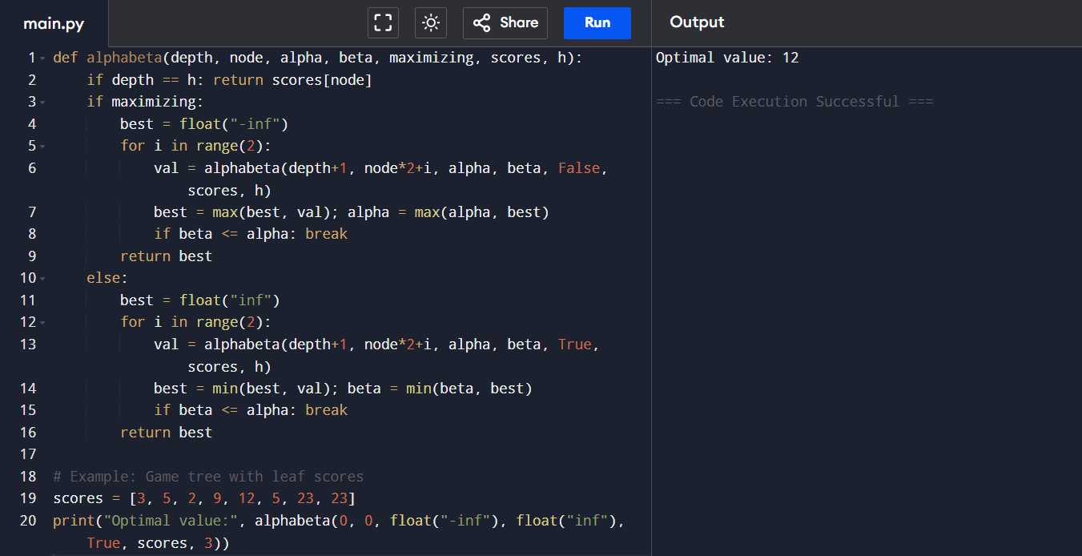

**EXPERIMENT 15:**

**EXPERIMENT 16:**

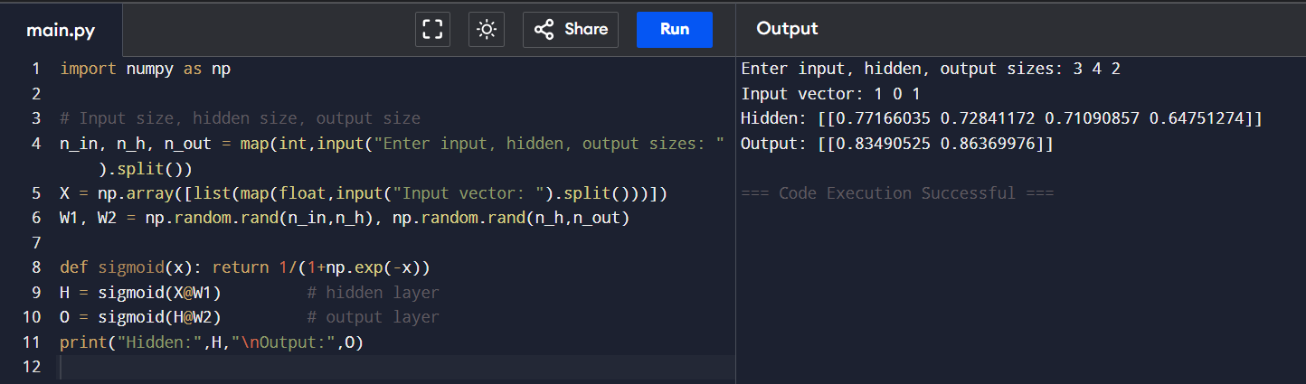

**EXPERIMENT 17:**